Service Tax No.: ACBFS041ASD001 PAN No.: ACBFS804 I A

T H E U N P A R A L L E L E D

PF Code : DL-22780
ESIC Code : 69000464950001001
SUKHMAA SONS & ASSOCIATES
242/2, Yadvindra Estate, Sukhmaa Tower, Behind Telephone Exchange,
SeCtOr-12A, Old Delhi Road, Gurgaon-122001 (Nr.) M 0124-4378198 E-mail : sukhmaasons@gmail.com

Mr. ………………………………………….. Date:
S/O Sri……………………………………… Date of Birth:………………………..
Mobile No:………………………………….
Address:…………………………………….

LETTER OF TEMPORAY OFFER

Dear Mr……………………………..,
Congratulations!!

As per the ‘200’Candidate Direct Joining on The .25/April/2018, you are being selected for the final round of interview which will be held in HONDA MOTORCYCLE & SCOOTER INDIA PVT LTD On successful completion of your final interview at plant site, you will be inducted as contractual staff on Sukhmaa roll for the period as per company norms.

- Your employment would be subject to the Terms & Conditions is subject to your successful completion of final round of interview and once you provide us all documents.
- Salary Gross : Rs.13600/
Employee PF contribution@12% on Basic, LWF & ESI@1.75 on Gross as per Govt norms
Canteen facility available (Subsidized)
Overtime: Rs.87, per hr rate
Other facilities Rs-600 coupon Tea & sancks
- Please bring along the below listed documents / details on your day of joining.
  - ITI ORIGINAL Certificates + (Two Copies )
  - Original Certificates ( 10th + Two Copies)
  - Eight passport size photographs (Recent)
  - PAN Card(Original)
  - Aadhaar Card(Original)
- Trad-FITTER,WEDER,TURNER,MACHINIST,PAINTER,MMV+DL,ELECTRICEAN+DL,DESAL MACANIC.
Wegt-50kg abave,Age Limit-18to25,passout-2013,2014,2015,2016,2017
Looking forward to a long and mutually beneficial career with us.(Addres- Sukhmaabuildcon flat no-401 vaitthalapur
Becharaji Ahmadabad Gujarat Yours truly,
Contact No-9810376506,7082380891
For SUKHMAA,

____________________________________
Authorised Signatory

I have read this letter in full & understand it fully. By signing this letter of offer, I accept all aforementioned terms & conditions of the contract of employment offered by SUKHMAA.

Accepted
Sincerely,


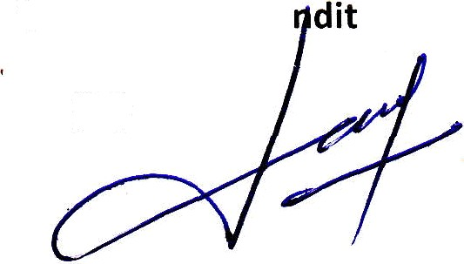

Chandeshwar Pa
(IR)

